
Sukkur IBA University
Department of Computer Science
Compiler Construction Lab

Lab # 00: C Programming Foundations for Compiler Construction & Environment Setup
Instructor: Muhammad Ismail Qureshi
Submission Profile
Name: Tushal Kumar Submission date (dd/mm/yy):
Marks obtained: Receiving authority name and signature:
Comments:
________________________________________________________________________________
Instructor Signature

Note: Submit this lab hand-out on LMS/e-learning before the next lab with attached solved activities and exercises
Lab Learning Objectives:
Upon successful completion of this experiment, the student will be able to:
- Set up, configure, and verify a native C compilation workflow (GCC, Terminal, VS Code).
- Understand lower-level C primitives critical for writing compilers: Pointers, Structs, File I/O, Dynamic Memory Management (malloc/free), and String Handling.
- Construct basic memory-managed data structures (Linked Lists) used in AST and Symbol Table design.

Lab Hardware and Software Required:
• GCC Compiler (MinGW-w64 for Windows, native GCC on Linux/macOS)
• Visual Studio Code / Code::Blocks / C IDE
• Terminal / Command Prompt
• PC
Background Theory:
Compilers read raw text files, build structured data representations in memory, process tokens, and output binary or assembly instructions. Higher-level abstractions are built using core C concepts:
- Pointers & Memory: Compilers traverse parse trees and graphs using memory addresses. Direct pointer access is necessary for efficiency.
- Structures (struct): Tokens, AST nodes, and symbol table rows are organized using C structures.
- Dynamic Memory (malloc/calloc/free): The size of source code being compiled is unknown at compile-time. Compilers dynamically allocate memory on the heap during execution.
- File I/O (fopen/fgetc/fclose): Lexical analyzers process source code character-by-character from disk stream buffers.
Forward and statical buffer.

Lab Examples:

Activity: Swap Two Variables Using Pointers (Pass-by-Reference)

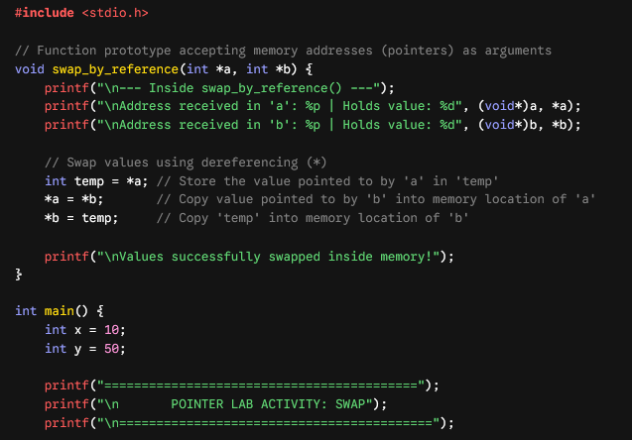

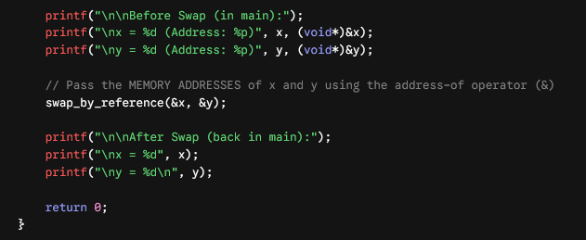

Example 1: Demonstrating Lexical vs. Block Scope in C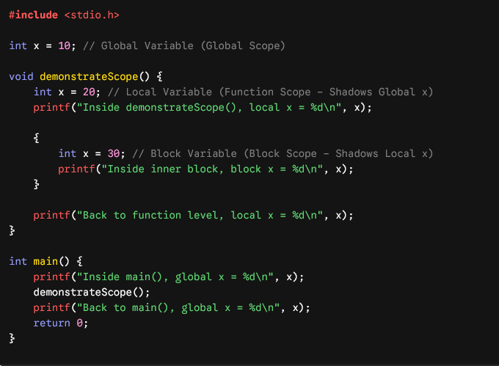

Example 2: Static vs. Automatic Storage Duration (Binding & State)

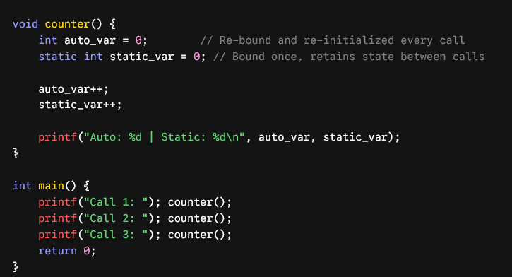

Lab Activities:

Activity 1: Environment and State Tracking

role of an Environment.
• Environment ($σ$ or $ρ$): A formal mapping function defined as $\text{Env}:\text{Identifier}→\text{Location}$. It answers the question: "Which memory slot does this variable name refer to in the current scope?"
• L-value (Location Value): Represents a memory address capable of holding data (e.g., 0x7ffe4b2). It is called an "l-value" because it typically appears on the left side of an assignment operator (e.g., x = ...).
• State ($σ$ or $μ$): The counterpart to the Environment. It maps memory locations to actual stored values ($\text{Store}:\text{Location}→\text{Value}$). It answers the question: "What binary value is currently sitting inside this memory slot?"

Environment vs. State

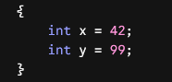

During execution, the compiler and runtime maintain the mapping in two lookup steps:

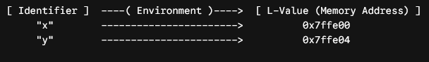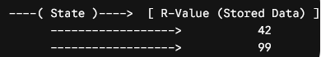
- Environment lookup: x resolves to memory location 0x7ffe00.
- State lookup: Memory location 0x7ffe00 resolves to the r-value 42.

Key Distinctions for Compiler Design
- Static Scoping (Lexical Scope): Environment bindings are determined at compile-time by the nesting structure of source code blocks.
- Dynamic Scoping: Environment bindings depend on the runtime execution call stack.
- Symbol Table Role: In a compiler frontend, the Symbol Table acts as the static representation of the Environment, tracking identifiers, their scope levels, data types, and allocated stack offsets (l-values).
Predict the output of the following C program by tracing the environment (variable bindings) and state (stored values) at each line. Write the output and explain how block scoping affects the environment.
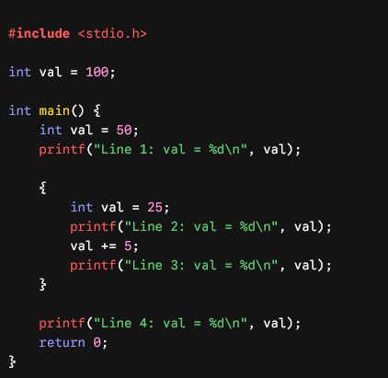

Activity 2: Environment Setup Verification
Open your terminal/command line and compile your code using GCC directly:
- Open terminal and run: gcc --version
- Save your file as scope_test.c.
- Compile using: gcc scope_test.c -o scope_test
- Run the executable: ./scope_test (Linux/Mac) or scope_test.exe (Windows).
Fundamental Pointer Operations
A pointer variable stores the memory address of another variable.
- & (Address-of Operator): Retrieves the memory address of a variable.
- * (Dereference Operator): Accesses or modifies the value at the memory address stored in a pointer.
Activity 3: Fundamental Pointer Operations

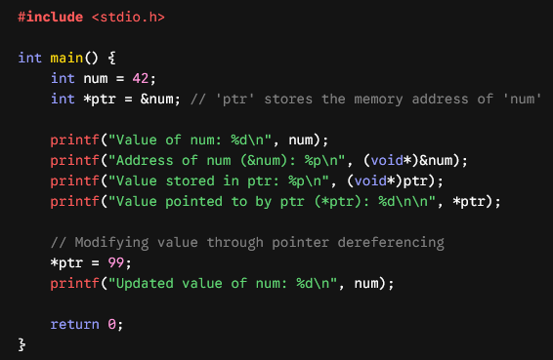
Activity 4: Dynamic Array Allocation and Resizing

Dynamic Memory Allocation Functions (<stdlib.h>)
The standard library provides four core functions for heap memory management:
- malloc(size_t size): Allocates size uninitialized bytes on the heap.
- calloc(size_t num, size_t size): Allocates space for num elements of size bytes each, initializing all bytes to zero.
- realloc(void *ptr, size_t new_size): Resizes an existing heap allocation preserving existing data.
- free(void *ptr): Releases heap memory back to the operating system.
Practical Example 1: Dynamic Array Allocation and Resizing
When compiling code, buffers (like token lists) must grow dynamically as more source text is read.
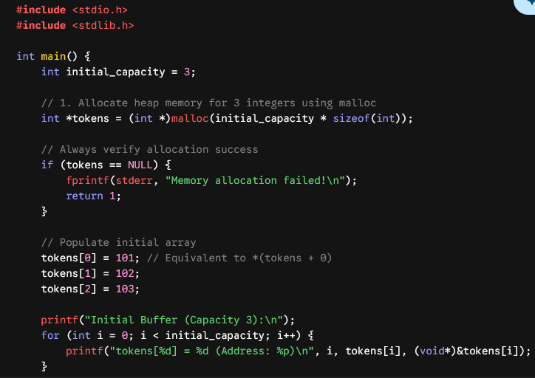
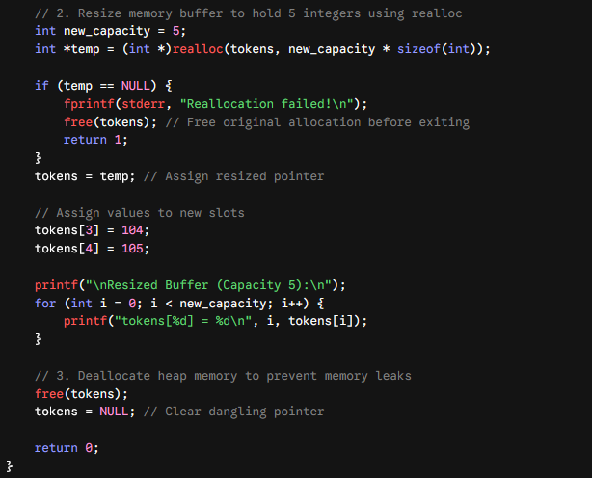

Practical Example 2: Pointers with Structures and Dynamic Nodes
Dynamic nodes are essential for building Abstract Syntax Trees (ASTs) or compiler Symbol Tables.
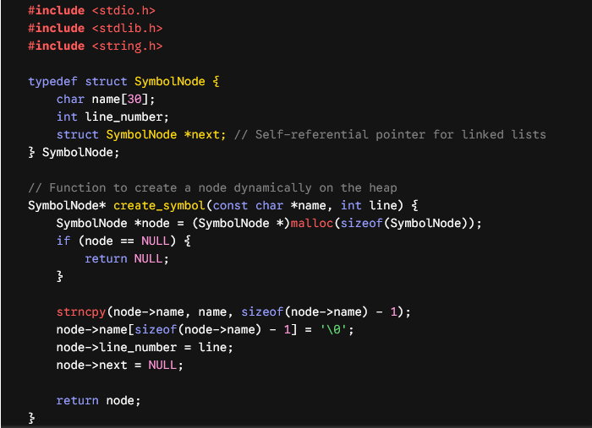
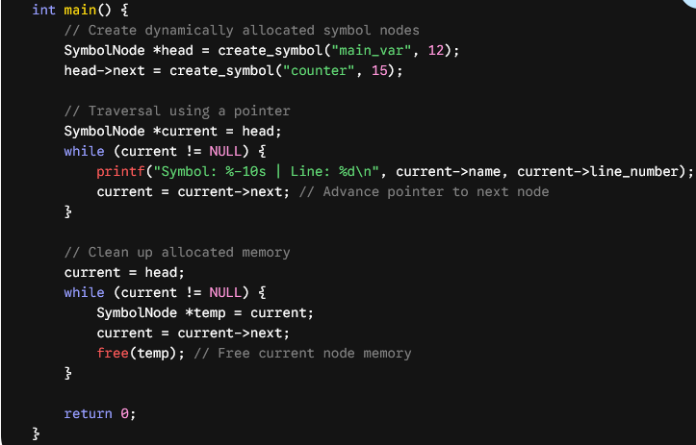
Lab Exercises:

Exercise 1: Nested Scope Resolution Simulator
Write a C program with at least three levels of nested block scopes inside main().
- Declare a variable int count at global scope and in each block level.
- Assign distinct initial values to count at each level.
- Print the address (&count) and value of count inside each block level to verify how memory locations (l-values) differ even when variable names are identical.

Exercise 2: Simulating a Simple Symbol Table
Write a C program that simulates a basic Symbol Table record for scope binding using a structure:
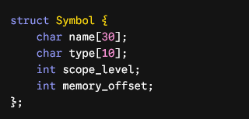
Define an array of 3 Symbol structures, populate them with dummy variable entries (e.g., x, y, z at different scope levels), and print the symbol table contents in a formatted tabular layout.

Exercise 3: Dynamic Scope vs. Static Scope Analysis
C uses Static (Lexical) Scoping. Analyze the following code snippet:
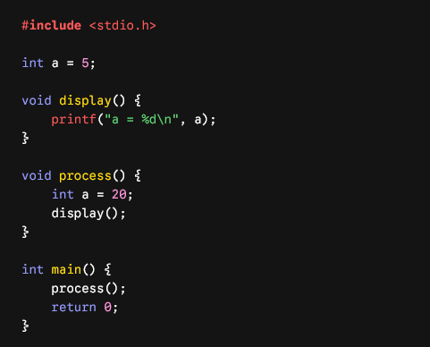
• Task A: Compile and run the program. What is the actual output?
• Task B: Explain why the output is obtained under C's Static Scoping rules.
• Task C: If C used Dynamic Scoping (resolving variables using the calling stack rather than text structure), what would the output have been?

